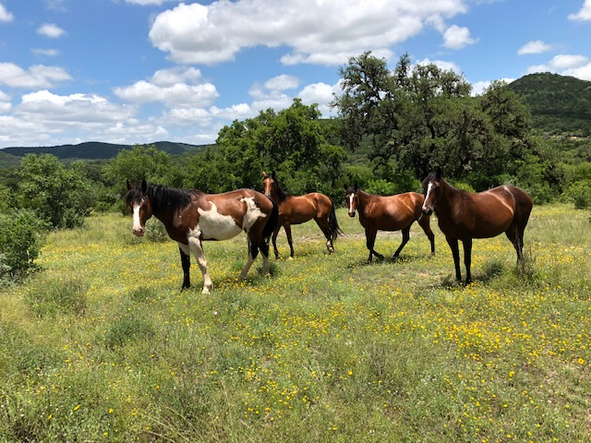  Our Mission:  1. To be a collective voice in the State of Texas against any person or entity, governmental or otherwise that challenges or seeks in any way to undermine the rights of property owners.  2. To support law enforcement agencies in their efforts to serve and protect the property of the citizens of Texas.  3. To provide educational information and resources on subjects and endeavors relating to property owners rights and our rural lifestyle.  Current board members are:  ​Don Phillips, President, Bandera  Wilson Toudouze, Vice President, San Antonio  Jeff Bearden, Treasurer, Medina  Robert Aguirre, Secretary, Pipe Creek |  | https://www.rlatx.org  rlaoftexas@gmail.com  Ranchers and Landowners Association of Texas P.O. Box 1164 Bandera, TX 78003 Tel 830-328-2653 |  | Ranchers and Landowners Association of Texas  - Our Members:  - Private property landowners,  - those with vested interest in land,  - those who lease land, and  - those employed by landowners.

Contact us:  Tel: 830-328-2653  Email: rlaoftexas@gmail.com  https://www.rlatx.org  ____________________________  The Association is working to address the concerns of its members for the following:  - Property Owners Rights: Water, Land use restrictions, and legislative issues.  - Law Enforcement: Property protection, poaching, trespassing, livestock and game protection, and criminal prosecution of offenders.  - Cash Rewards: for information leading to the arrest and conviction of any person or persons committing crimes against its members' agricultural property, livestock, or wildlife.  - Support of youth programs: Agricultural and scholastic achievements, good citizenship, and gun and hunting safety |  | The Power of One…  Voice  Benefits of membership: Adding your voice to the voices of others creating a more powerful voice for these important issues: Property protection, water rights, land-use management, education, and more.  The Ranchers and Landowners Association of Texas supports the efforts of the fine men and women of our Law Enforcement Departments and The State of Texas Parks and Wildlife Department.  Annual Membership Levels:  $25 – Individual  $45 – Family  $50 – Business  If you wish to offer additional support:  $75 – Silver Level  $100 – Gold Level |  | - Become a member:  - https://www.rlatx.org/become-a-member.html  - __________________________________  - Or mail a check or money order to  - Ranchers and Landowners  - Association of Texas  - P.O. Box 1164  - Bandera, TX 78003  - Please include your:  - _________________________________  - Name  - _________________________________  - Family member name (if joining)  - _________________________________  - Mailing Address  - _________________________________  - Telephone  - _________________________________  - Email Address

